**Trees: Spring 2015 MT2 Q4c**

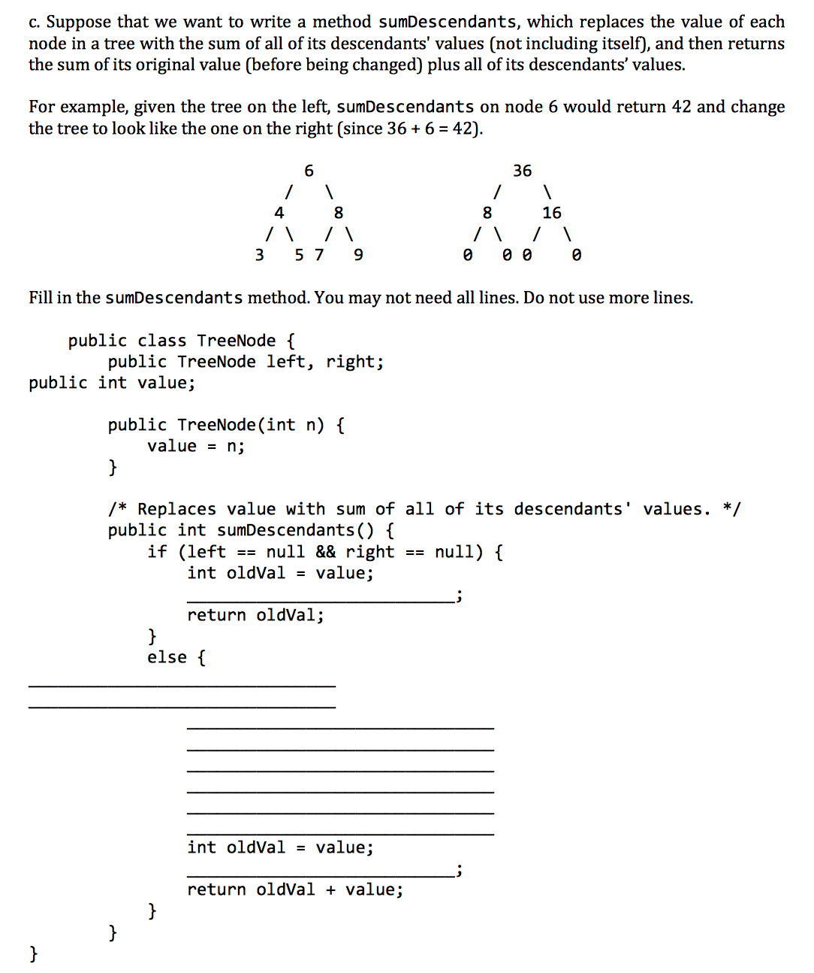

**Iterators: Fall 2014 MT1 Q5**

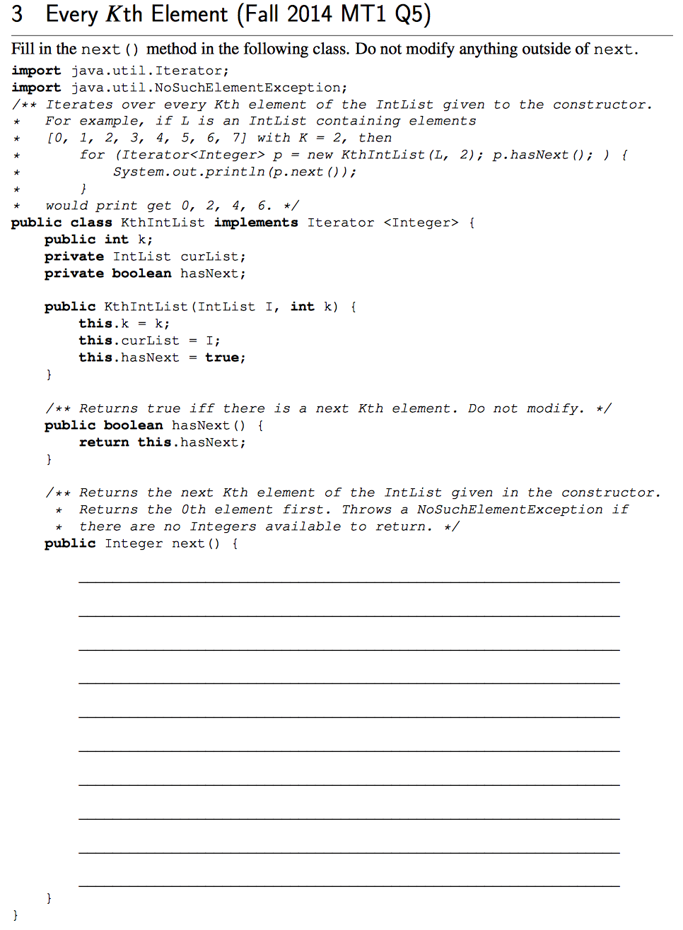

**BST: Spring 2016 MT2 Q7**

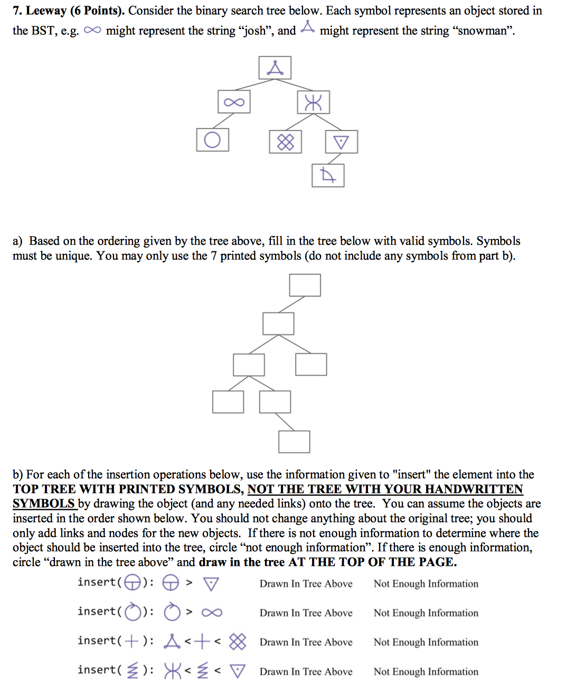

**Asymptotics: Spring 2016 MT2 Q9**

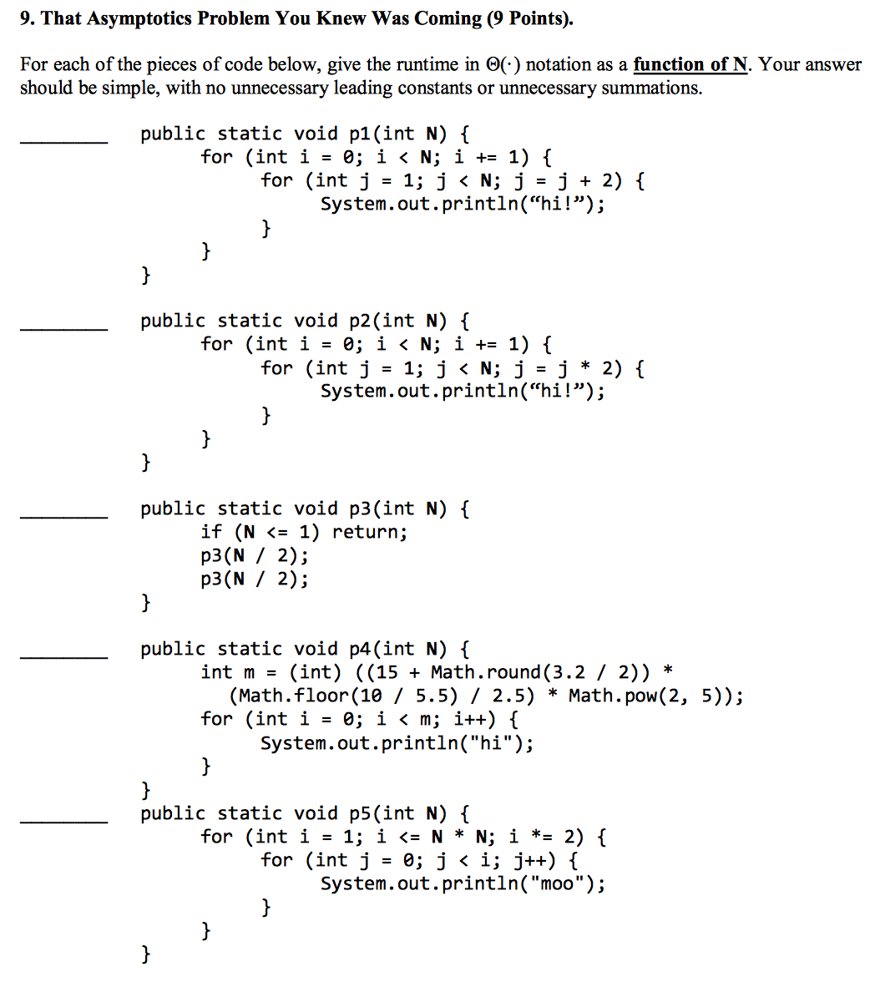

**Asymptotics: Spring 2015 MT2 Q5**

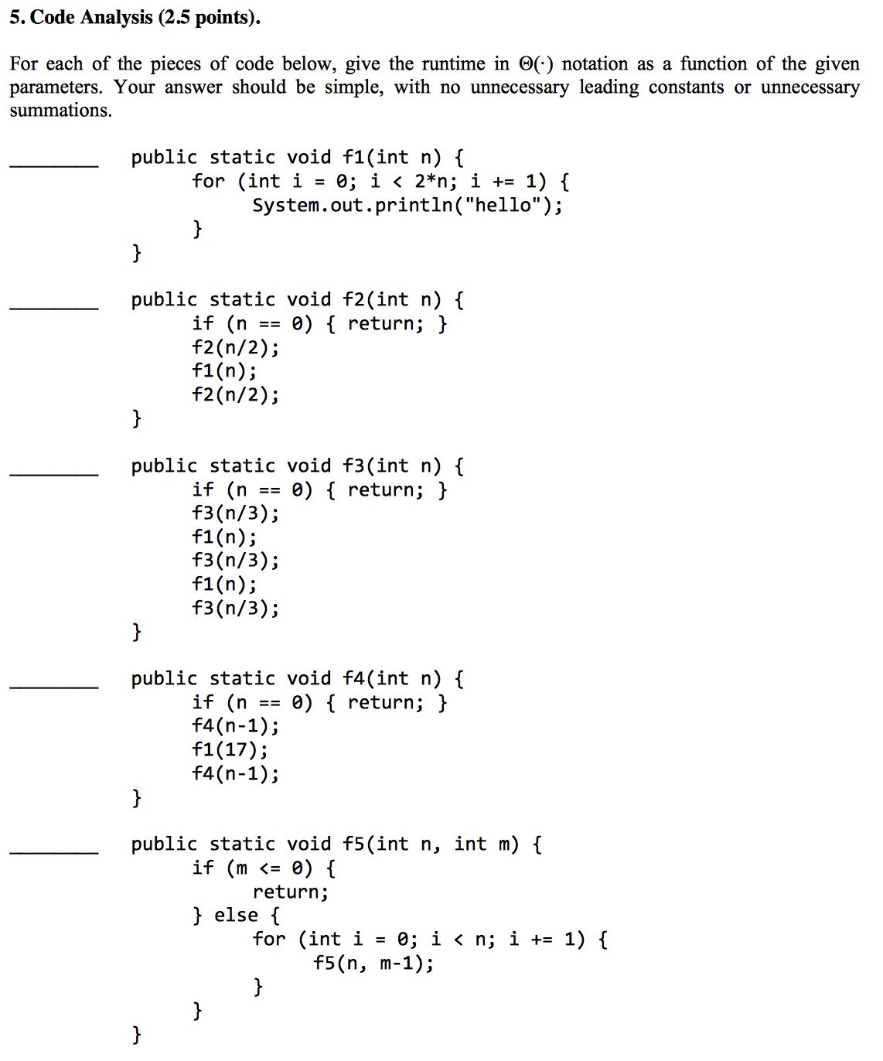

**Hashing Runtimes: Fall 2016 MT2 Q3**

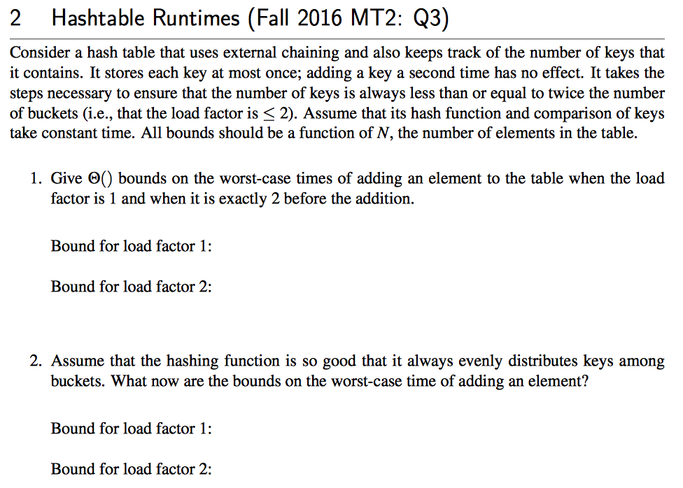

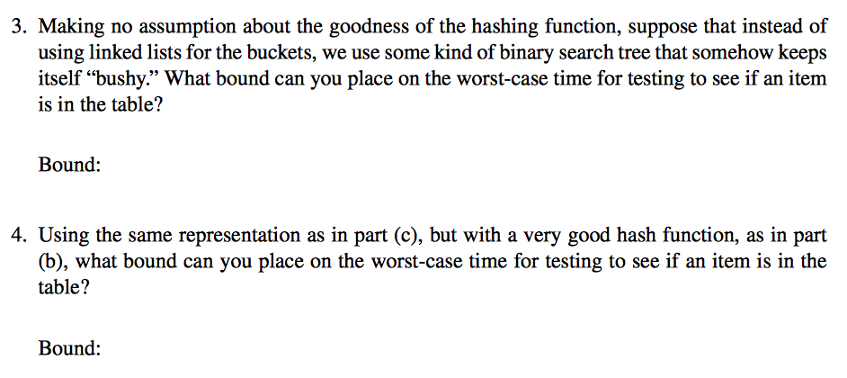

**BST/Hash Table: Spring 2016 MT2 Q1**

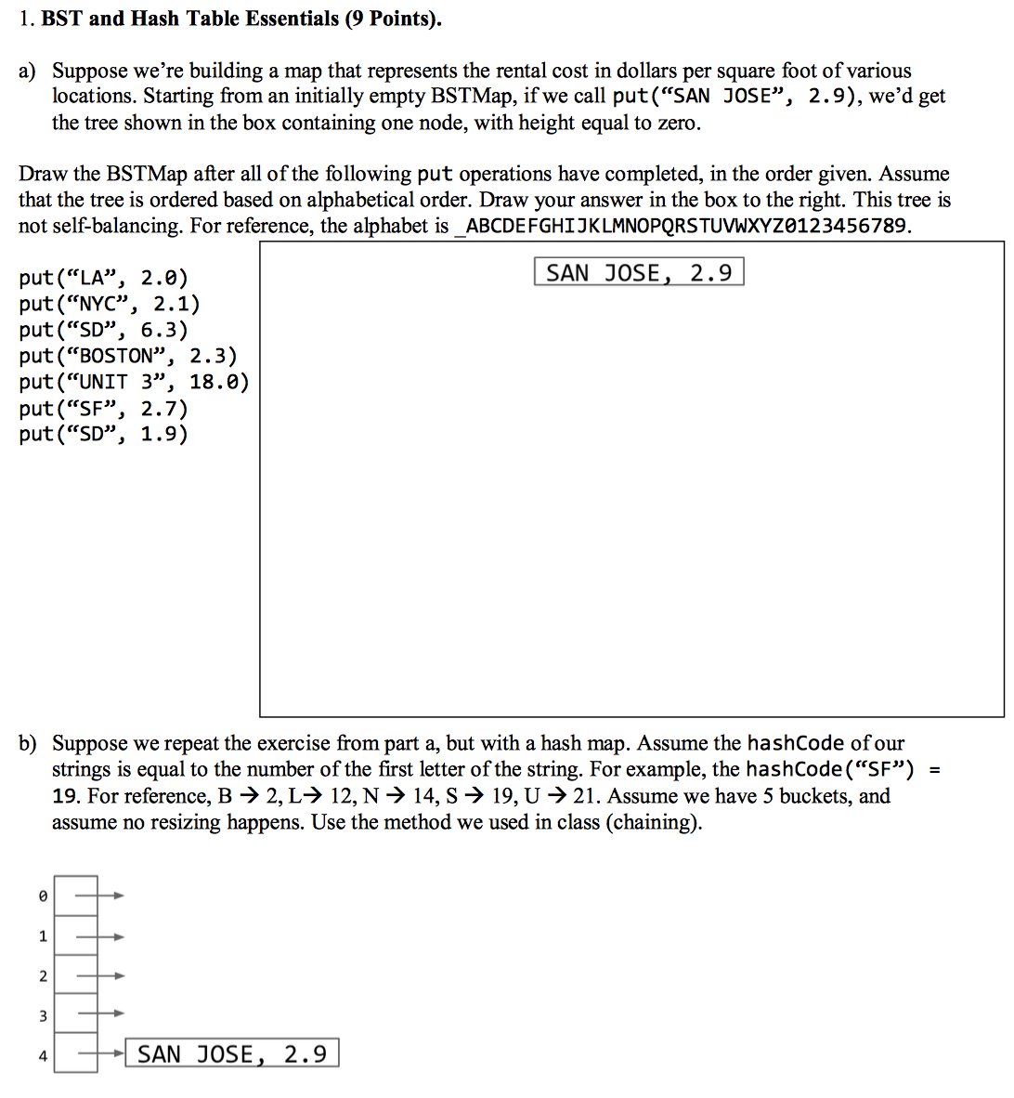

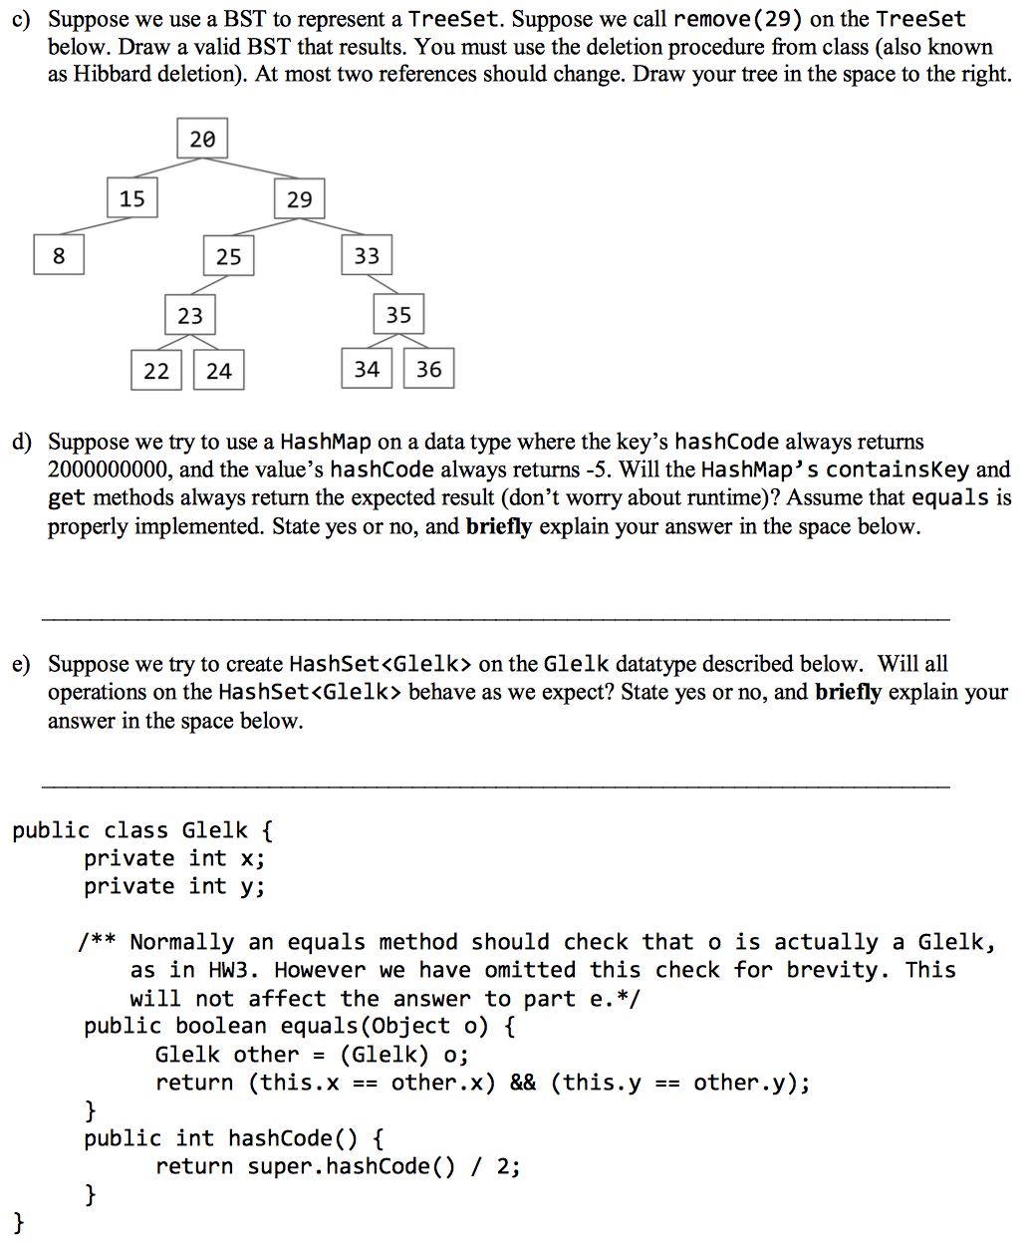

**Trees: Summer 2016 MT2 Q7**